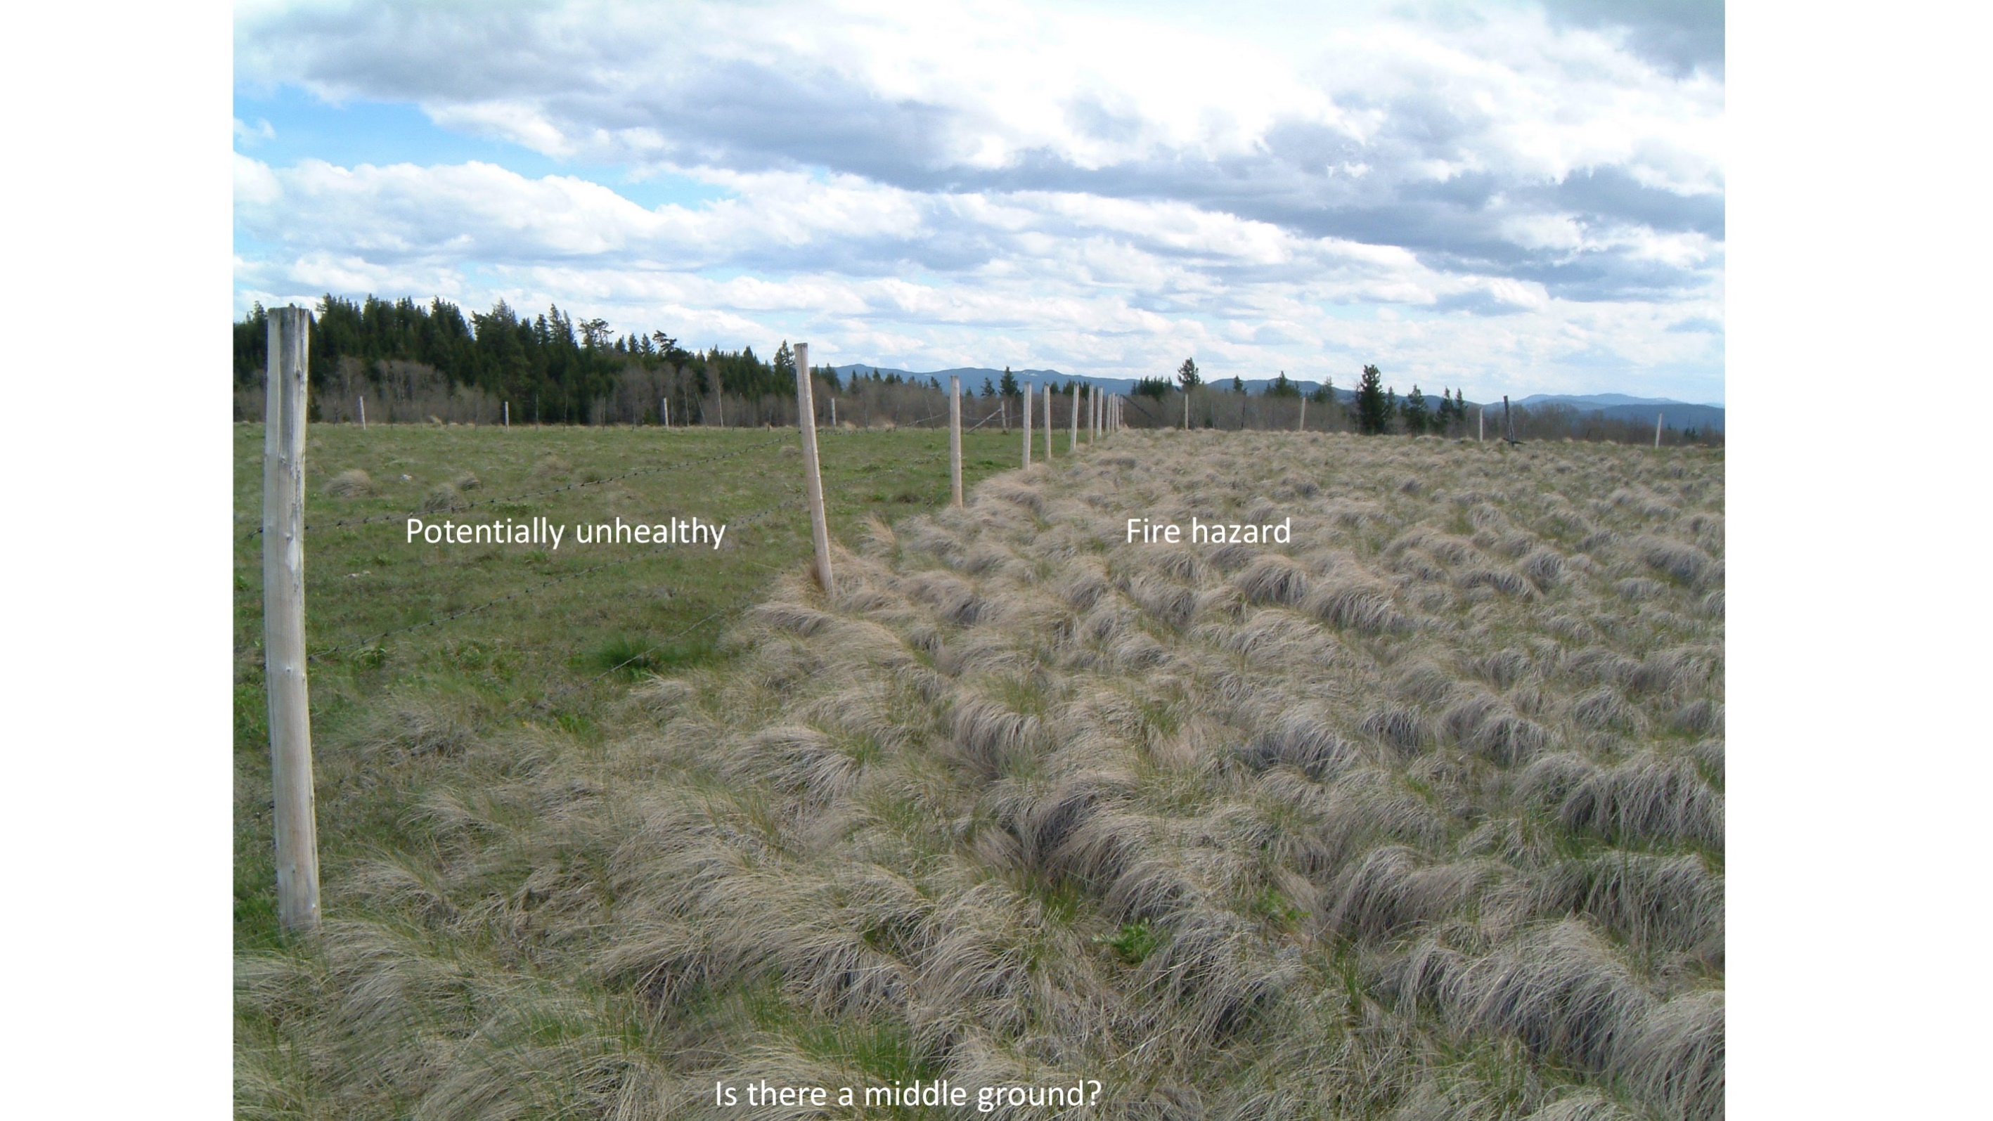

Fine Fuel Reduction Through Targeted Grazing

**October 27th, 2020**

**Background**

* 2017-18 fire seasons showed value of agricultural practices, notably grazing, in changing fire behaviour by helping slow, turn, or stop fires
  + **‘Agricultural Firebreaks’**
* British Columbia Cattlemen’s Association partnered with provincial agencies and local partners to develop a pilot program to investigate wildfire risk reduction through targeted grazing
* Targeted cattle grazing will be used to reduce/break up fine fuel loads and wildfire risk next to communities, utilities, and transportation corridors

Targeted grazing is:

“the use of a specified kind of livestock at a determined season, duration, and intensity to accomplish defined vegetation and landscape goals“

* Most fuel management projects focus on tree canopy characteristics - removal of trees, decreasing # of trees per hectare, changing species, and/or pruning/removing understory
* I**ncreased herbaceous material 🡪** volatile and easily ignited fuel type
  + **The goal is to reduce fine fuel loads/break up fuel continuity while ensuring that other values are not negatively impacted**

**Monitoring**

Monitoring occurs in an ‘area of interest’ within 2km from community infrastructure, intensive data collection is concentrated within 400m of infrastructure.

1. ***Intensive*** – occurs after grazing is completed for the season, once a year on macroplot areas, providing data at a level that can be used for statistical analysis.
2. ***Extensive*** – occurs every two weeks during the grazing period over a larger portion of the pilot area, intended to provide broad assessments of grazing effects (e.g., spatial patterns of grazing, fuel continuity) and alerts to unanticipated benefits or problems.

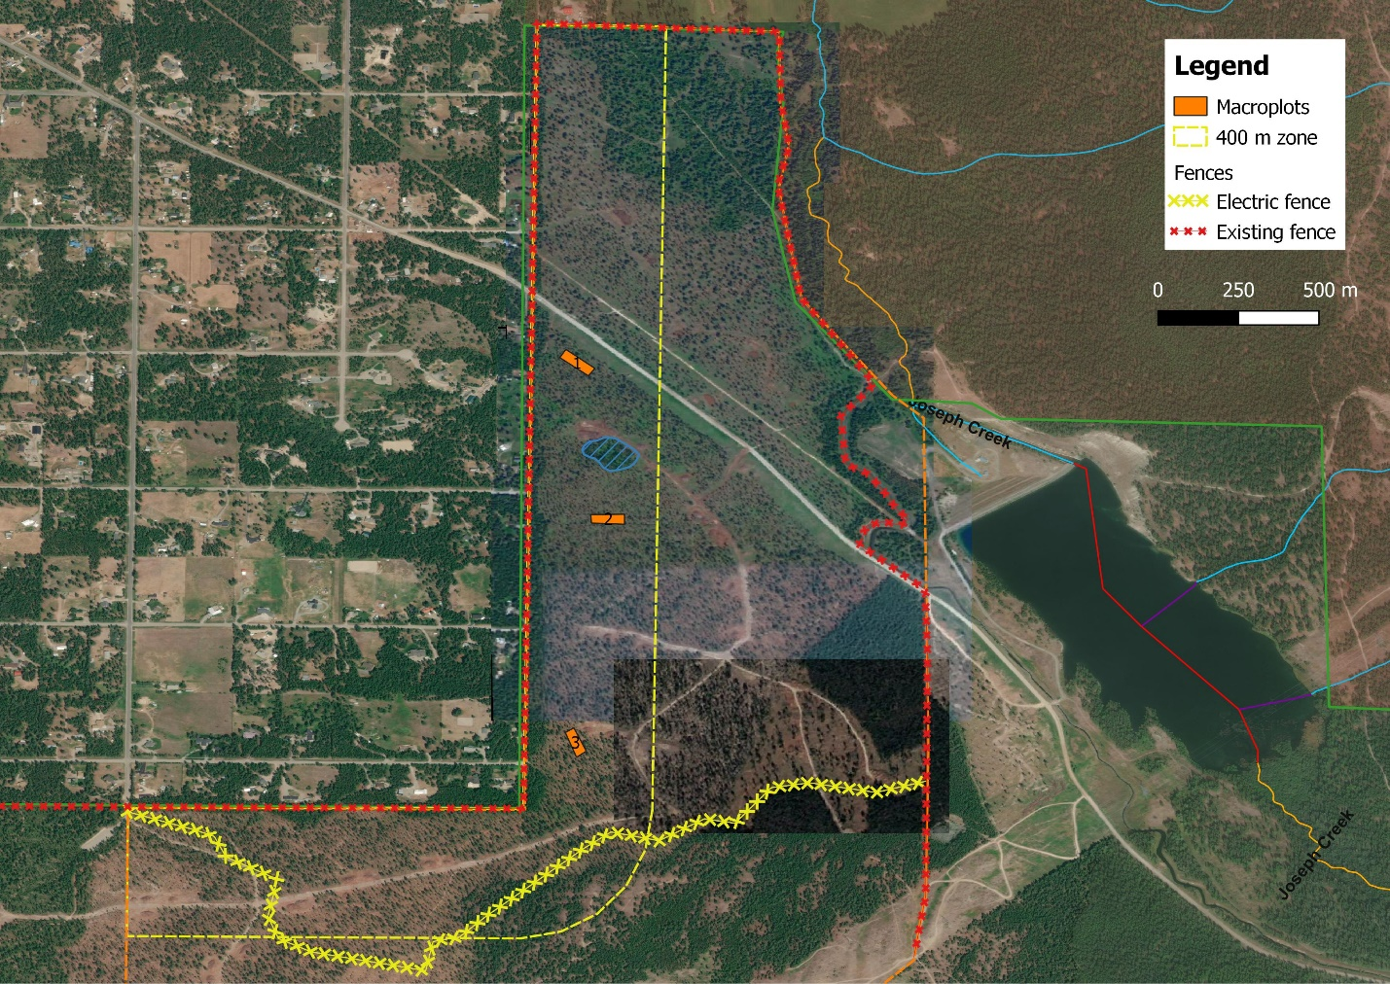

Extensive Monitoring Variables:

|  |  |  |
| --- | --- | --- |
| **Extensive Monitoring Level** | **Method Overview** | **Sampling Variables** |
| **Basic** | A visually based determination of the grazing effect at randomized plots located across various pre-stratified types | Per Plot:   * Slope * Aspect * Distance from stock water * Canopy cover (%) and stubble heights of top 2-3 understory species * Grazing use (%) * Fuel pattern (continuous, sparse, or sporadic) |
| **Specific** | Additional specific monitoring identified through need or interest.  A high priority emphasis at Summerland in 2020 was riparian areas and wetlands. Riparian health assessments occurred every two weeks during grazing to provide information on cattle impact. | Riparian health through the riparian function checklist |

Intensive Monitoring Variables:

|  |  |  |
| --- | --- | --- |
| **Primary Variable** | **Plot Type** | **Number of Plots** |
| **Plant biomass including shrubs** | 0.5m2 caged/uncaged | 15 caged/uncaged |
| **Litter biomass (standing and down)** | 0.5m2 caged/uncaged | 15 caged/uncaged |
| **Fine woody fuel biomass (< 0.6 cm)** | 0.5m2 caged/uncaged | 15 caged/uncaged |
| **Plant identification and cover** | 0.5m2 caged/uncaged, 0.1m2 | 15 caged/uncaged, 150 |
| **Litter cover (standing and downed)** | 0.5m2 caged/uncaged, 0.1m2 | 15 caged/uncaged, 150 |
| **Substrate cover (e.g., soil, biocrust)** | 0.5m2 caged/uncaged, 0.1m2 | 15 caged/uncaged, 150 |
| **Woody fuel cover in 3 categories** | 0.5m2 caged/uncaged, 0.1m2 | 15 caged/uncaged, 150 |
| **Plant height** | 0.5m2 caged/uncaged, 100-m transect | 30 caged/uncaged, 150 |
| **Woody fuel height in 3 categories** | 0.5m2 caged/uncaged | 15 caged/uncaged |
| **Fuel moisture content (plants only)** | 0.5m2 caged/uncaged | 30 caged/uncaged |
| **Fine fuel continuity (grasses only)** | 100-m transect | 150 segments |
| **Conifer regeneration** | 3.99 m diameter | 6 |
| **Occurrence of soil movement** | 30 m x 37 m area | 3 |
| **Occurrence of soil capping, crusting, compaction** | 30 m x 37 m area | 3 |
| **Occurrence of plant recruitment** | 30 m x 37 m area | 3 |
| **Occurrence of biological soil crusts** | 30 m x 37 m area | 3 |
| **Occurrence of nitrogen fixing forbs and shrubs** | 30 m x 37 m area | 3 |



Macroplot Design - A 30 m x 100 m macroplot broken into five 12.5 m x 30 m segments for the purpose of locating caged and uncaged plots. A central 30 m x 37.5 m area is reserved for plant community, conifer regeneration, and range health sampling. A 100-m bisecting baseline transect will be used for stubble height and fuel continuity assessments.

**Grazing**

|  |  |  |  |
| --- | --- | --- | --- |
| **Date range** | **AU** | **Type (Cow-calf/steer)** | **Grazing area (ha) mapped** |
| July 29-Aug 12 | 160 | Cow/calf | 183 |
| July 29-Aug 12 | 9 (6 bulls @ 1.5 AUE) | Bulls | 183 |

* Distribution was even across the pasture with consistent use of the main pinegrass/western fescue plant community
  + An electric fence was used to concentrate grazing animals in the portion of the pasture adjacent to settlement areas. This area was 183 ha in size with an estimated stocking rate of **103 AUMs**

**Extensive Results:**

* Use of current year’s growth was between 0-85%, with an average use rate of 24%, which appears to sufficiently address fuel loading issues without negative ecological impacts

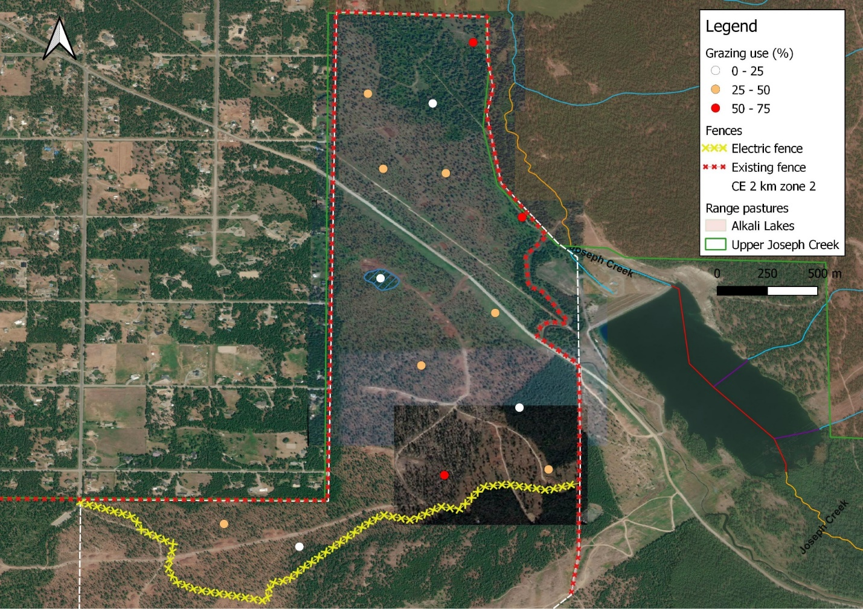

Grazing Use in Upper Joseph Creek Pasture - Heat map of grazing use from extensive monitoring assessment August 12, 2020. This includes wildlife and cattle use.

* Fuel loading was continuous in nature across the majority of the pasture, mainly due to the rhizomatous growth nature of the primary forage species in the pasture (pinegrass)

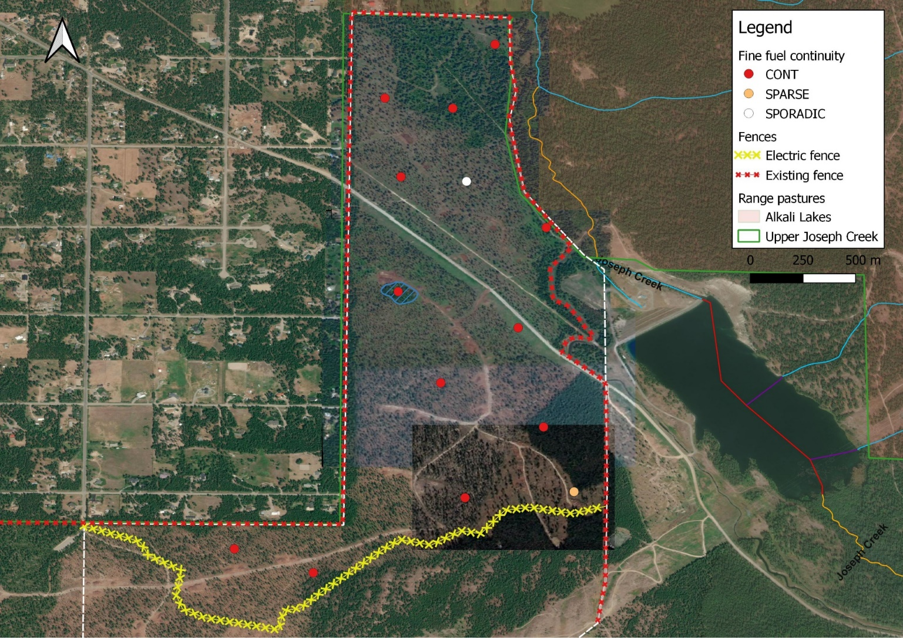

Fuel Loading in Upper Joseph Creek Pasture – Heat map of fine fuel loading assessed during extensive monitoring August 12, 2020. Fine fuel loading is continuous across the bulk of the pasture.

**Intensive Results:**

Plant communities characterized - allows us to monitor plant community changes and shifts in ecological status/integrity from grazing treatments

* + Douglas Fir-Larch/Pinegrass-Western Fescue

Table 1. Effect of grazing treatment on biomass (kg/ha)

|  |  |  |  |  |
| --- | --- | --- | --- | --- |
|  | Caged | Uncaged | P-value | Reduction (%) |
| Forbs | 22.0 | 17.7 | 0.6647 | NA |
| Other grasses | 90.4 | 33.1 | 0.2110 | NA |
| Litter | 25.5 | 63.6 | 0.0156 | -149.7 |
| Pinegrass | 140.5 | 111.9 | 0.3445 | NA |
| Shrubs | 57.6 | 24.0 | 0.0034 | 58.3 |
| All grasses | **230.9** | **144.9** | **0.0274** | **37.2** |
| Total living biomass | **310.5** | **186.7** | **0.0099** | **39.9** |
| Total biomass | **336.0** | **250.3** | **0.0308** | **25.5** |

* + Grass biomass and total living biomass was significantly different between caged non-grazed controls and grazed samples – approximately 40% reduction in biomass under grazing treatment

Table 2. Effect of grazing treatment on pinegrass height (cm)

|  |  |  |  |
| --- | --- | --- | --- |
|  | Height (cm) | |  |
|  | **Caged** | **Uncaged** | **P-value** |
| Pinegrass height | **34.3** | **22.7** | **0.0027** |

* + Grazing treatment significantly reduced height of pinegrass relative to controls – grazing treatment effectively reduced standing fine fuel heights! This has impacts on fire behaviour and spread

Fuel discontinuity ratings per macroplot, based on gap size (continuous low fuel segments) and quality (Sp and Sd, vs Cont1 and Cont2).

* Lowest value (1) is Sd, 2=Sp, 3=Cont2, 4=Cont1
* Look for continuous runs of 1's or 2's for good fuel breaks

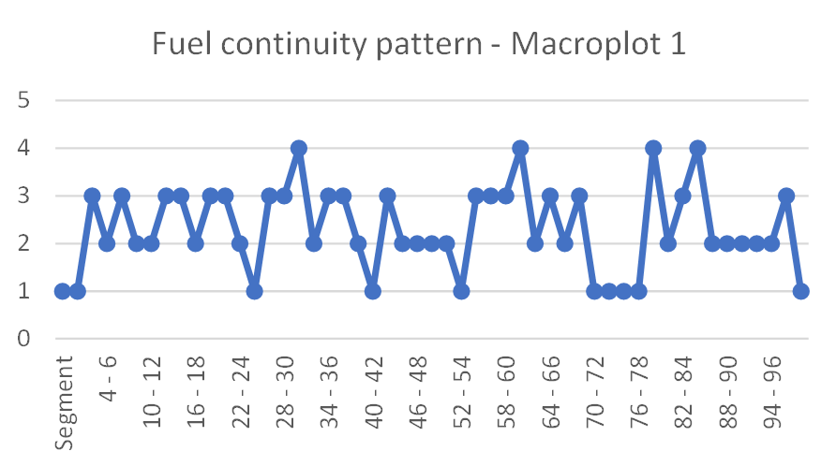

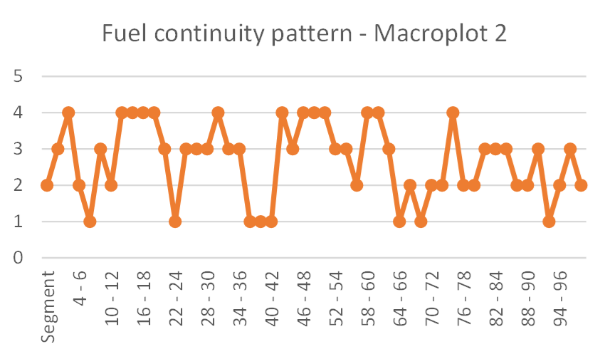

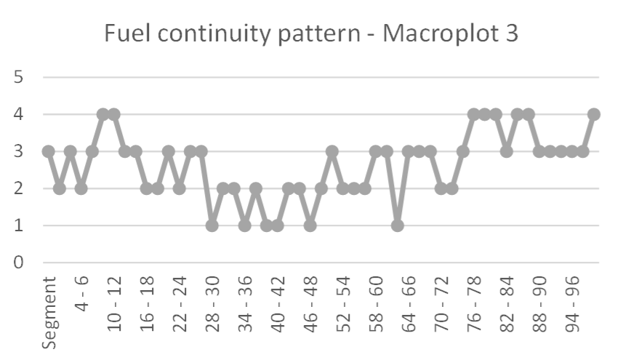

* + Macroplot 3, between segment 30 and 48 has a good fuel break which may be what we are trying to achieve

Range Health Assessments for 2020

|  |  |  |
| --- | --- | --- |
| **Macroplot** | **Range Health Score** | **Details** |
| **1** | **Properly Functioning Condition** | * Subsurface soil layers may be compacted from logging machinery on fine soils * Community dominated by CARU due to previous canopy coverage, but FECA and FEID noted * Forb layer and shrub layer reduced, potentially due to ungulate use or from previous overstory canopy * Good litter layer, vigorous growth of dominant graminoid species (pinegrass) * No evidence of excessive soil movement or erosion |
| **2** | **Properly Functioning Condition** | * Some soil compaction from harvesting activities noted * Healthy litter levels and well developed LFH layer * Community lacks tall shrubs and has limited forb component, potentially from ungulate use or from previous overstory canopy * Vigorous growth of dominant graminoid species (pinegrass) * No evidence of excessive soil movement or erosion |
| **3** | **Properly Functioning Condition** | * Good coverage of soil surface by vegetation litter and well developed LFH * There may be some compaction issues from timber harvest machinery on fine soils * Limited diversity due to heavier previous forest canopy   + Tall shrub layer is missing, forb layer is reduced * Vigorous growth of dominant graminoid species (pinegrass) * No evidence of excessive soil movement or erosion |

Rangeland health was indicative of healthy functioning upland systems. We want to track range health trend over years to see if treatment has any impact on function.

**Conclusions and Considerations**